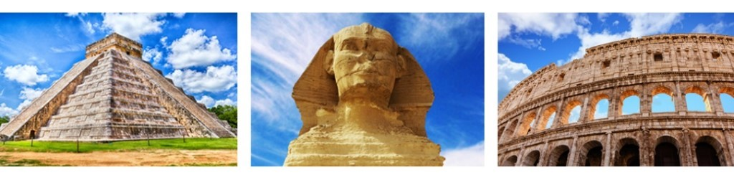
Lab: Virtual Archaeology
Created by Emily Bartz, Anthropology PhD Student
Name:___________________________________________ Date: ___________________
For this labyou will experiment with some different facets of virtual archaeology. Virtual Reality (VR) allows individuals to experience archaeological sites and individual artifacts from around the world using 3-D simulation, often from the comfort of their own homes.
Part One: SketchFab (sketchfab.com)
1. Click on either of these models of houses from the famous Neolithic site of Skara Braein the Orkney Islands, Scotland, excavated by V. Gordon Childe.
House 1
House 2
Move the cursor to rotate the point of view around. Click on the numbers embedded within the image to learn more about the individual house features or histories.
How does this experience compare to viewing photographs of the houses? ___It gives a surreal experience as if you are living in that house
How do you get a better sense of these as “pit houses” or semi-subterranean compared to photos?
- It feels like a real life experience.
How do you think this enhanced viewing compares to actually visiting the site (and you can’t go into the houses when you’re there)? It gives an experience which one can’t get when visiting the place. When you visit the place you will not get that 3D experience of the underground.
2. Stonehenge is a popular site for modelers to recreate. Click on all three models to compare. Zoom in and out, move the cursor for different views, and click on the embedded numbers.
Stonehenge 1 (the stone circle in its current ruined shape)
Stonehenge 2 (the stone circle, reconstructed as it might have appeared, inside the henge)
Stonehenge 3 (the Stonehenge landscape as determined by LiDAR; Stonehenge is #1)
Which one do you like the best and why? What are the pros and cons? I like the Stonehenge 3. It gives a better view of the landscape and how it was well planned as compared to the rest which were just close.
Do you get a sense of the scale of the monument and landscape from these models? Why or why not? ___yes, I got to experience how people in the Stone Age period lived in orderly structures.
Why is it important to have these three (and more) VR models of Stonehenge? It gives us an understanding of how life was in the Stone Age times and makes us appreciate what we have currently.
What did you learn that was unknown or unexpected about Stonehenge by visually manipulating these models? It was an expected to me how there was orderly structures.
3. Find your (or another) UNESCO World Cultural Heritage site, on Sketchfab or CyArk.
CyArk.org is dedicated to preserving heritage sites through 3D documentation.
Which site? (If not your chosen site, some other site of interest): Taj mahal
Did viewing the computer model help you better visualize or learn about your site, compared to just doing library research on it? Explain View
The computer model gave me a better view and understanding of how the building looks.

Part Two: Immersive experiences with VR headsets
______________________________________________________________________________

Watch the video: Students 'Visit' Lost Archaeological Site in Virtual Reality (4:24)
Using VR headsets, the experience of visiting an Assyrian Palace at ancient Nimrud, Iraq, destroyed by ISIS fighters, is recreated.
Watch the video: Virtual reality allows visitors see ancient Rome palace(5:03)
In this video tourists at the imperial Roman Domus Aurea, now underground and in ruins, can experience the palace as it once existed, at ground level with

Explain the additional value of an immersive virtual visit, compared with watching 3D manipulation on a screen: This give you the view of the people as if you are on that given location.
From these examples, discuss how the use of VR headsets may help “replace” archaeological sites that are now destroyed or too remote or dangerous to physically visit. VR may replace the visiting locations but at the same time there will be that need to have the real life thrill. VR will preserve the historic sites that may be destroyed by wars.
How else might VR technology change archaeology now and in the future? Technology will play a big role in preservation of the sites. It can be very useful in such pandemic times to continue the experience of the sites from afar.

